Justify! PPT Key

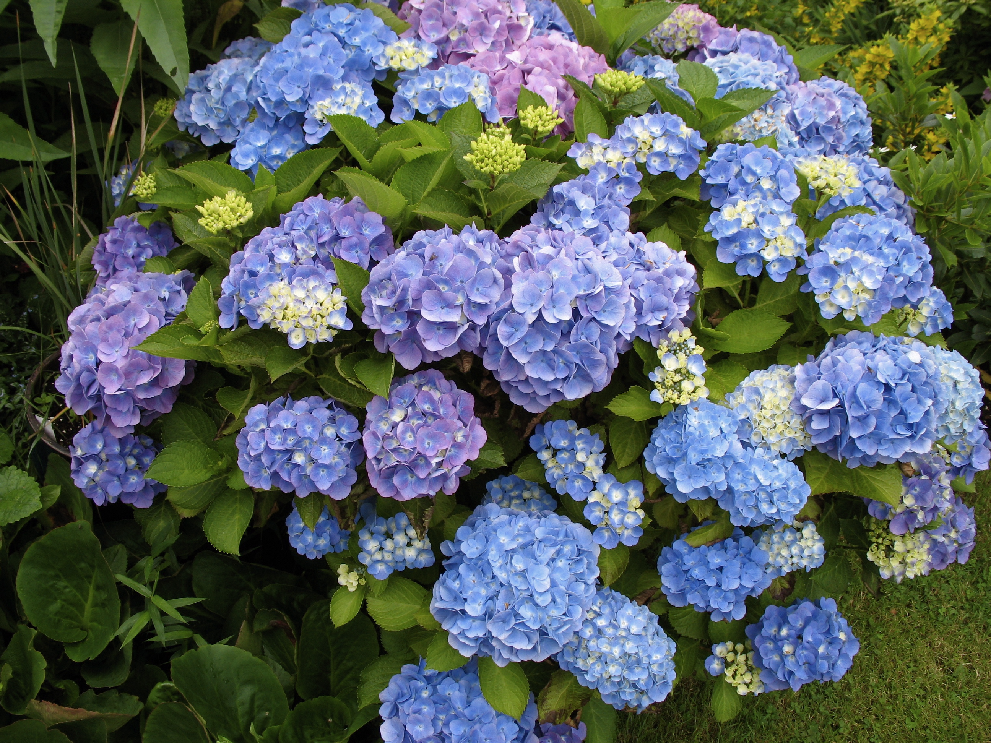
Acquired trait: Hydrangea blooms can be different colors on the same plant depending on the chemical makeup of the soil.
https://commons.wikimedia.org/wiki/File:Hydrangea_macrophylla_02.jpg
I, MJJR, CC BY 2.5 <https://creativecommons.org/licenses/by/2.5>, via Wikimedia Commons

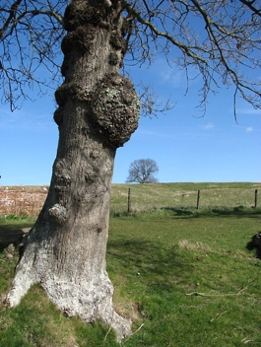
Acquired trait: The rounded deformations (burls on the tree trunk) are caused by some form of stress—injury, virus, or fungus.
https://commons.wikimedia.org/wiki/File:Growth_on_tree_trunk_-_geograph.org.uk_-_724687.jpg
Evelyn Simak / Growth on tree trunk

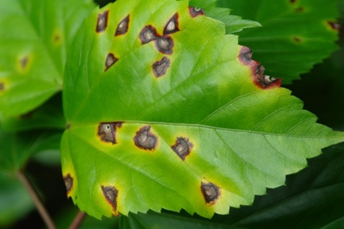
Acquired trait: Leaf spots can be caused by fungal, bacterial, or viral plant diseases. Whitish spots in the middle are dead cells. However, the spots can also be caused by abiotic factors including environmental factors, toxins, and herbicides.
https://commons.wikimedia.org/wiki/File:Hibiscus_Bacterial_leaf_spot_caused_by_Pseudomonas_cichorii_(5684575818).jpg
Scot Nelson from USA, CC0, via Wikimedia Commons

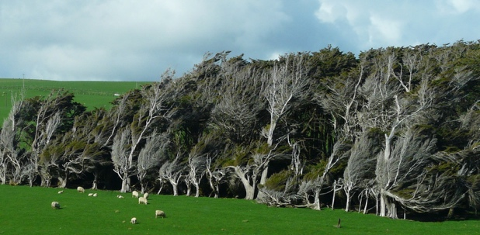
Acquired trait: The trees are shaped and bent into strange leaning forms by the constant force of the southerly winds. These trees are found at Slope Point, the most southerly point of the South Island of New Zealand.
https://commons.wikimedia.org/wiki/File:Slope_point_is_the_most_Southerly_point_of_the_South_Island._The_ever_present_force_of_the_Southerly_winds_carves_the_trees_into_surreal_forms._-_panoramio.jpg
grumpylumixuser, CC BY 3.0 <https://creativecommons.org/licenses/by/3.0>, via Wikimedia Commons

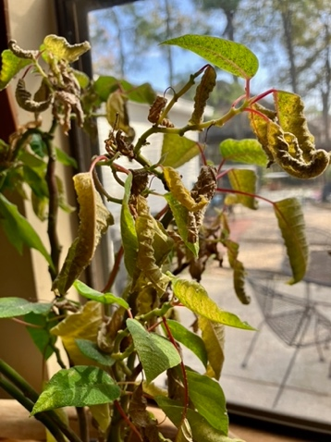
Acquired trait: The curled, yellowing leaves on this plant are the result of insufficient watering.
Photo credit: L. Garay

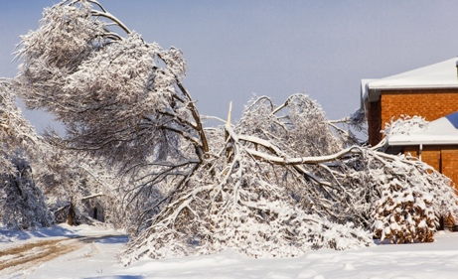
Acquired trait: This tree’s bent and broken trunk and limbs are the result of ice storm.
https://commons.wikimedia.org/wiki/File:2013_12_26_Ice_Storm_aftermath_(20117785224).jpg
David Zhang from Canada, CC BY-SA 2.0 <https://creativecommons.org/licenses/by-sa/2.0>, via Wikimedia Commons

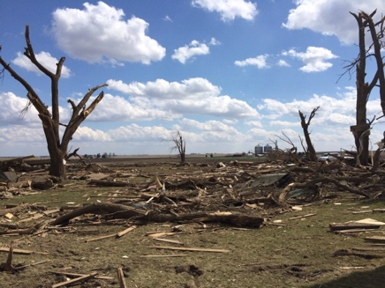
Acquired trait: These broken trunks and limbs are due to tornado damage.
https://commons.wikimedia.org/wiki/File:2015-04-09_Rochelle,_Illinois_tornado_farmstead_damage.jpg
National Weather Service, Public domain, via Wikimedia Commons

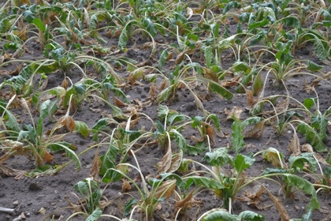
Acquired trait: The brown and dead leaves on these sugar beets are the result of drought.
https://commons.wikimedia.org/wiki/File:Beta_vulgaris_subsp._vulgaris_var._altissima_drought_(04).jpg
Rasbak, CC BY-SA 3.0 <https://creativecommons.org/licenses/by-sa/3.0>, via Wikimedia Commons

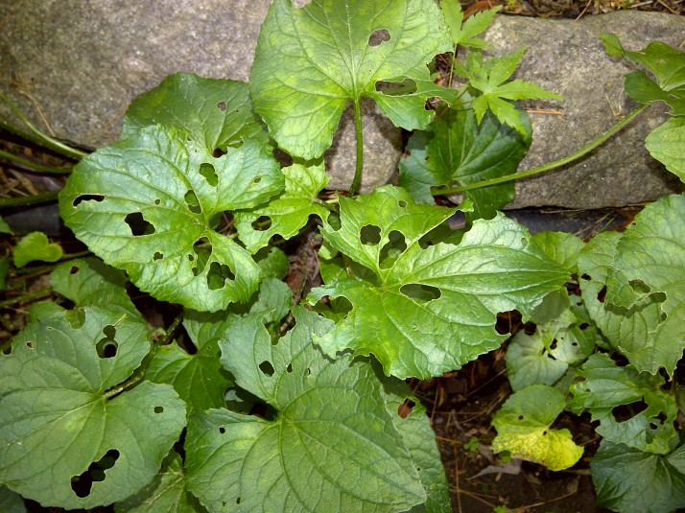
Acquired trait: The leaves have holes made by insects.
This Photo by Unknown Author is licensed under CC BY-ND

