Science Journal:
Pill Bug Investigation

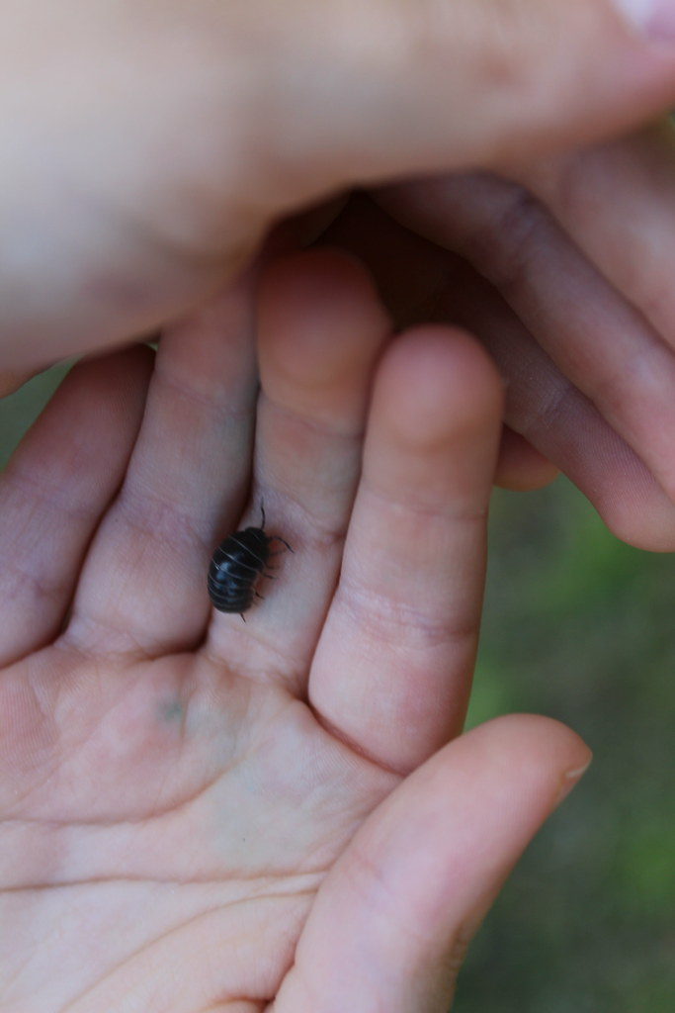
"IMG_5044" by roamingwab is licensed under CC BY-NC 2.0

Name: __________________________________

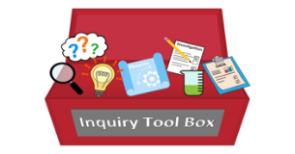
Getting Started
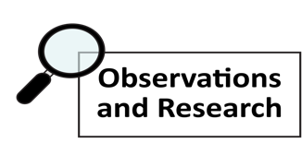
We would like to learn more about_________________________________________________________.

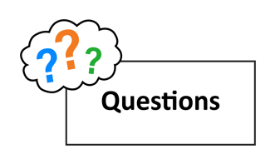
The question we will investigate is __________________________________________________________.

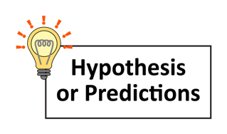
We predict pill bugs will eat
because

___________________ .
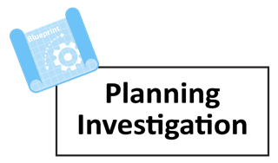
We think we should__________________________________________________
____________________________________________________________________________________
because_____________________________________________________________________________
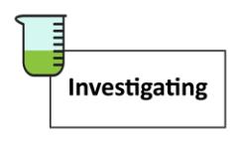

Day 1 Date:

- What did you see the pill bugs doing today?

Today the pill bugs are

- Describe what their food looks like today.

Today I noticed that the food

Day 2 Date:

- What did you see the pill bugs doing today?

Today the pill bugs are

- Describe what the food in the habitat looks like today.

Today I noticed that the food

Day 3 Date:

- What did you see the pill bugs doing today?

Today the pill bugs are

- Describe what the food in the habitat looks like today.

Today I noticed that the food

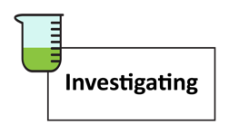Day 4

Day 4 Date:

- What did you see the pill bugs doing today?

Today the pill bugs are

- Describe what the food in the habitat looks like today.

Today I noticed that the food

Day 5

Day 5 Date:

- What did you see the pill bugs doing today?

Today the pill bugs are

- Describe what the food in the habitat looks like today.

Today I noticed that the food

